Hampton Newport News Community Services Board
South-Eastern Family Project (SEFP)
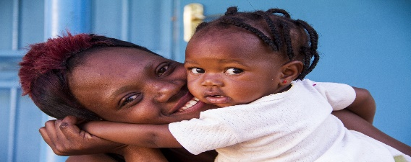
WHO ARE WE?

SEFP is a licensed substance use disorder residential treatment program for pregnant and recently post-partum women and their infants. The program works with residents to build a stable and healthy lifestyle, provides recovery support services, parent education and counseling, and planning for community re-integration. We are a program of the Hampton-Newport News Community Services Board located in Newport News, Virginia
WHAT ARE SEFP’S OVERALL GOALS?
- To provide gender specific treatment services based upon the clinical need.
- To improve pregnancy, stabilization and recovery outcomes for women enrolled in treatment.
- To have infants born healthy without the effects of substance use.

WHO CAN ENROLL INTO SEFP?

SEFP is open to pregnant and recently post-partum Virginia residents who are at least 18 years of age and have a primary diagnosis of substance use disorder.

CAN I ENROLL IMMEDIATELY?

Bed Availability fluctuates on a daily basis. Please contact us to discuss availability.

WHAT ARE SOME OF THE SERVICES OFFERED AT SEFP?
- Education on recovery and relapse prevention
- Substance use disorder and co-occurring mental health education (group and individual)
- Evidenced-based treatment addressing the unique needs of women with substance related disorders
- Trauma Informed Care
- Peer Recovery Support services
- Direct linkage to medication assisted treatment services
- Comprehensive case management services
- After care planning, community support, and linkage to needed resources

HOW LONG CAN I RESIDE AT SEFP?
The program is designed to serve the residents based on individual need in a person-centered treatment environment, which encourages stabilization.
For information about SEFP, please see our program’s site at https://sefp.org or call/email us for additional information:

Phone: 757-245-1070
Email: sefpinfo@hnncsb.org

