Military Cultural Competency and Transition Awareness:
Working with Service Members, Veterans, and their Families
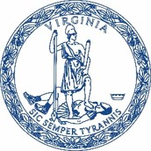
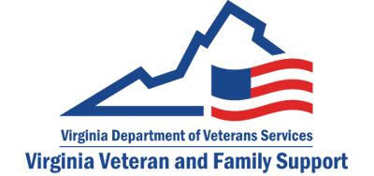
Presented by: Virginia Veteran and Family Support
Virginia Department of Veteran Services

This training provides an overview of military culture to include:

It is intended to assist state agencies, community partners and behavioral health providers in better understanding, communicating and effectively interacting with military members, veterans, and their families.

Upcoming Training Dates and links to register (ctrl + click to access link):

July 9, 2024, 9-11am: register here
August 14, 2024, 1-3pm: register here
September 12, 2024, 9-11am: register here
October 8, 2024, 1-3pm: register here
November 19, 2024, 9-11am: register here
December 11, 2024, 1-3pm: register here

For questions and additional information, please contact:
Lauren Mathew at Lauren.mathew@dvs.virginia.gov

