Our Mission Makes Us a
Standout!



The mission of
Blue Ridge Behavioral Healthcare
is to provide quality community-based services that prevent and address mental health disorders, intellectual disabilities, and substance disorders.

Notes___________________________________________________________________________________________________________________________________
______________________________________

Serving the Cities of Roanoke and Salem, and Counties of Botetourt, Craig, and Roanoke, Virginia

Your Recovery is Worth the Stay!

Crisis Stabilization & Detoxification Services

RITA J. GLINEIKI
RECOVERY CENTER

For admission information or questions call 540-344-6208

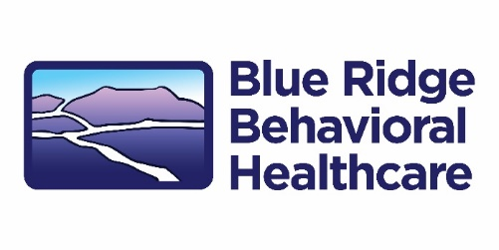

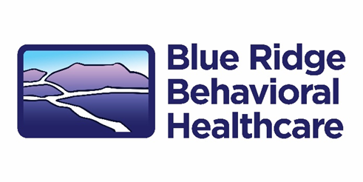

Crisis Stabilization & Detoxification Services



RITA J. GLINEIKI
RECOVERY CENTER

For admission information or questions,
call 540-344-6208

Your call is confidential

For admission information or questions call 540-344-6208

BRBH Crisis Stabilization Unit
is a welcoming residential program providing short-term,
person-centered
mental health crisis stabilization, medical and clinical detoxification, and substance use recovery services.

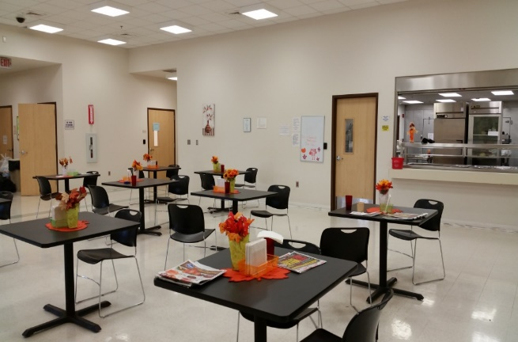

Our program includes:

- 16 bed facility

- Staffed by therapists, clinicians, nurses, residential aides, peers, doctors, and nurse practitioner

- Length of stay is flexible, depending on need

- We can be a supportive step-down environment from inpatient psychiatric hospitalization, promoting ongoing stability after discharge

- We will work with you to assess your needs in areas of physical health, mental health, substance use, social, housing, legal, advocacy, and transportation and establish a discharge plan with links to outpatient aftercare to address those needs

- 8 hours of scheduled programming, including a group, individual, and family therapy, case management, psycho-educational counseling, recreational and relaxation activities, assessment of physical health needs, and peer led activities

- We currently offer Suboxone for Medication Assisted Treatment

Admissions taken 24 hours a day, 7 days a week



We accept the following insurance:
Medicaid
Medicare
Anthem

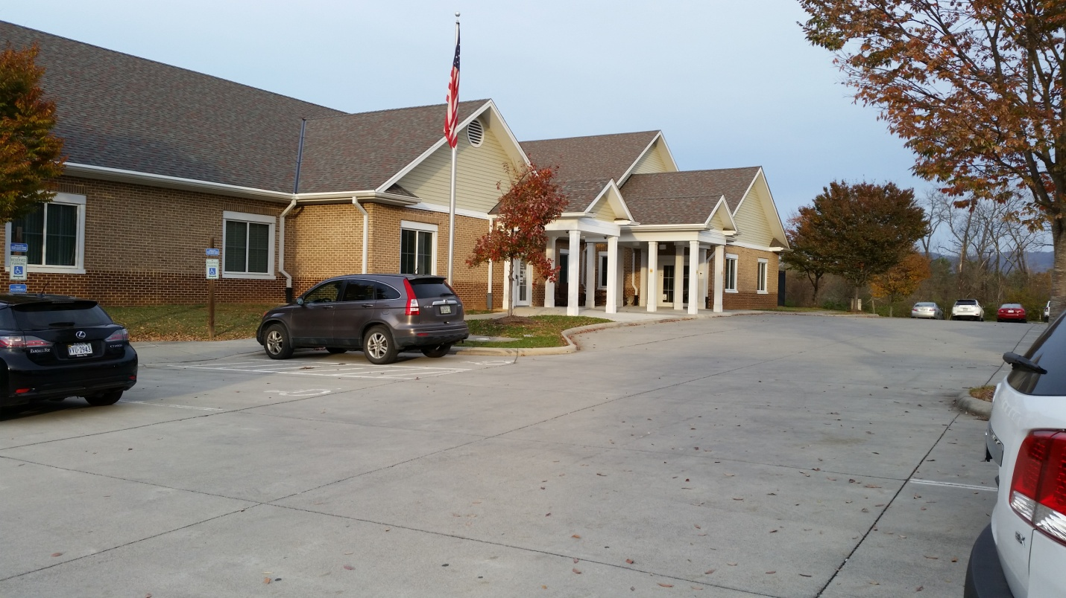

What you can expect:

- Assessment by a therapist and nurse when you arrive

- Clothing washed and storage of your personal belongings

- We are a no smoking facility but offer nicotine patches

- No cell phones allowed but we provide telephone opportunities each evening

- Full service kitchen with 3 meals and 3 snacks daily

- Weekly visitation

For admission information or questions call 540-344-6208

