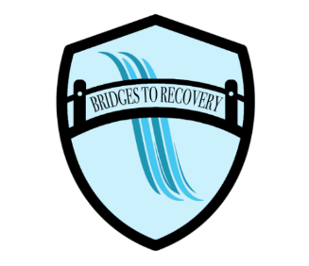

“We Start Together, We Stand Together, and We Graduate Together.”

Pre-Admission Information for Residential Programs
Congratulations on your decision to enter treatment. We realize that this is a courageous step and would like to take this opportunity to offer some guidelines to make transition into treatment smooth and comfortable.

- Bring a 30-day supply of any prescribed medication or over the counter (OTC) medicine that you routinely take. All prescribed medication must be in the original, correctly labeled container, and OTCs must be unopened, or they cannot be administered during treatment. If a resident becomes ill and needs medication, we must collect the co-payment at the time of order.
- The state of Virginia requires that you have a physical examination within 30 days of your admission and you should bring a copy of the results from your doctor.

- Take care of all medical, dental, and legal appointments prior to entering treatment. This may mean postponing appointments or court appearances until after discharge. Providers are often accommodating when they know you are preparing to come to Bridges to Recovery. Attorneys, for example, may be able to make scheduled court appearances in your absence, and we can verify your presence in treatment for the courts. The goal is to ensure that your treatment is as uninterrupted as possible.

- Bring Insurance/Medicaid cards with you. If your Medicaid has recently been closed, apply/reapply before you come in for admission. Verify before coming to treatment that you are current with DHHS, have not missed a review date and are not due for a review.

- On the day of admission, you will be assessed for temperature and Covid Test. The person providing your transportation to admission will be asked to wait until you are cleared for admission. This process usually takes about a half hour. Make sure you detox before the day of admission. A negative urine drug screen is not a requirement for admission.

- Housing after Treatment Do not rely on Bridges to Recovery to find you housing after treatment. The staff is committed to helping men create comprehensive aftercare plans to ensure ongoing recovery, yet we cannot guarantee housing.

- Telephone Calls & Visits. Telephone usage varies by program. Guidelines will be explained upon arrival at the facility. You may not have your cell phone while in Inpatient treatment, however, there are specified days and times that the facility phone may be used for personal calls.

- Meals. Inpatient Residents will be provided three meals per day. Additional snacks will be available. Residents will not be allowed to bring snacks to treatment or purchase snacks or soda while in treatment.

- Bring only what you need for treatment. Limit your belongings to one suitcase. Leave valuables at home and limit your cash to what you will need for emergencies. Bridges to Recovery will hold all valuables in a locked closet for protection. Once items are placed in the closet they will be held until graduation. We are unable to cash checks. Bridges to Recovery assumes no liability for the loss of money or personal property. We provide linens, laundry baskets, laundry soap, personal hygiene articles. Washers and Dryers are provided for your use at no charge.

- With pre-approval, packages and letters can be mailed to you on an emergency basis, c/o Bridges to Recovery at the appropriate facility’s address. Delivery is accepted during weekday business hours only. If you choose to send mail out, please bring the necessary postage. Please make sure you change your address after you graduate from BTR so that you will receive your mail.

