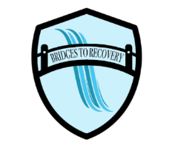
Bridges to Recovery
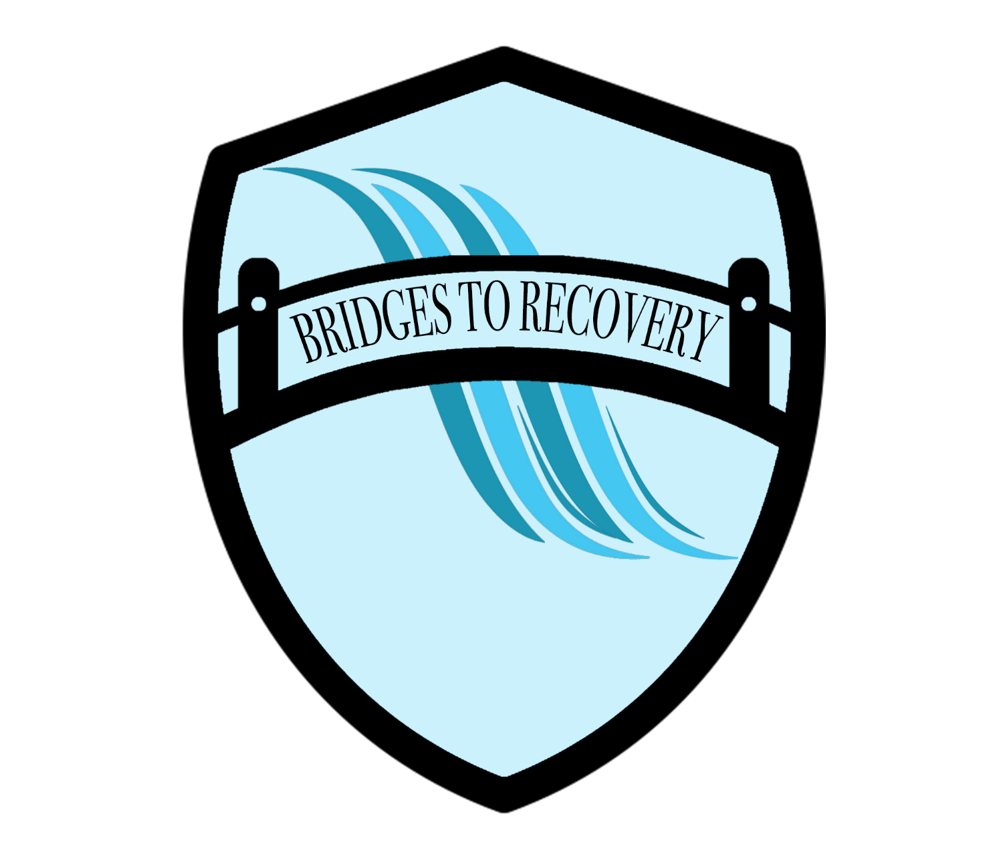
Resident’s Checklist of items you will need and those you will want to leave at home. Should you have any questions, please feel free to ask our Admissions staff.
What to bring:
- 30 – Day Supply of Cigarettes (no vapes)
- 30 – Day Supply of Medication (no over the counter)
- Five (5) Pair of Pants/Shorts
- Five (5) Shirts
- Five (7) Pair of Underwear
- Five (7) Pair of Socks
- Warm Coat/Sweatshirt
- Sleepwear
- Shoes and Slippers
- Exercise clothing
- Phone – will be collected by staff and given at specified times during treatment
We provide bodywash, toothbrush, toothpaste, shampoo, conditioner, deodorant, razor, shaving cream, comb, and nail kit.
What NOT to bring:
- Drugs, alcohol, paraphernalia
- Vapes
- Cameras, DVDs, Computers, or handheld games
- Perfume, aerosols, candles, incense, unnecessary valuables
- Hair dye, nail kits
- Products containing alcohol (e.g., Listerine)
- Food, coffee, tea, soda, cookies, or candy (Snack items are provided for you in the community center)
- Clothing, pictures, materials that are alcohol/drug related or illustrate violence toward women or revealing in any manner.
- Over the Counter medications or vitamins
- Expensive jewelry or clothing
- Guns, knives or any item that can be used as a weapon.

Please note that the safety of our residents and staff are our top priority so your bags will be searched at the time of admission. Random room searches will be conducted throughout your 30 days stay.

Any item(s) brought that is/are not listed on the “What to bring” list will be placed in a bag, taped, stored, and returned upon your discharge.

